F I R E D E P A R T M E N T

The City of New York
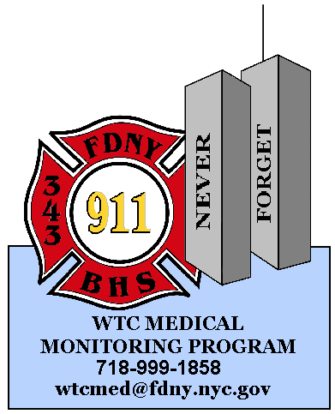 Bureau of Health Services

World Trade Center

Medical Monitoring & Treatment Programs
Sofia Bakradze
9 MetroTech Center
Brooklyn, N.Y. 11201
Phone: 718-999-1937
Fax : 718-999-0080

REQUEST FOR DUPLICATION OF WTC MEDICAL RECORD
PATIENT AUTHORIZATION FOR RELEASE OF MEDICAL INFORMATION TO NIOSH WTC CLINICS

Last Four Social ______________

First Name ________________________________ Last Name ________________________________ MI________

Address __________________________________________________________________________________________

City ____________________________________________________ State _______________ Zip______________

Home Phone # _________________________ Cell # _______________________ Work # ______________________

Please request/check all that apply:

I authorize The Fire Department of the City of New York/Bureau of Health Services to disclose medical information about my:

□⁭ World Trade Center Medical Monitoring Program physical examination records

□⁭ World Trade Center Medical Treatment Program physical health (BHS) visit(s)

⁭
TO: WTC Health Program Clinic site specified below:
________________________________________
________________________________________
________________________________________
________________________________________
________________________________________

Reason for disclosure: ⁭ Patient Request ⁭ Other

We will not condition treatment or payment on whether you sign this authorization. However, if you refuse to sign, we will not release your records.

Patient
Signature: ________________________________________________________________ Date: _____________

For records related to World Trade Center Medical Treatment Program mental health/substance abuse (CSU) visit(s), please call Shara Pena at 212-570-1693.

To request records or to revoke authorization, send a written request to the address at the top of this page.

